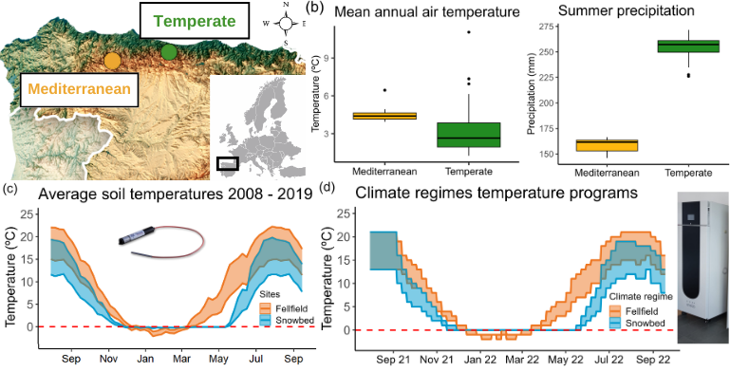

FIgure 1. Study community description.

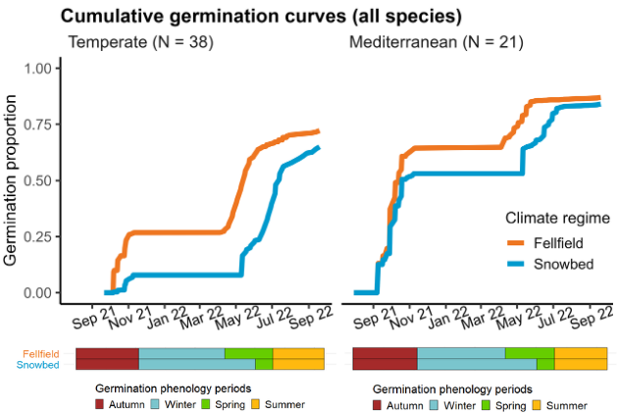

Figure 2. Representation of the cumulative germination curves of the two study communities.

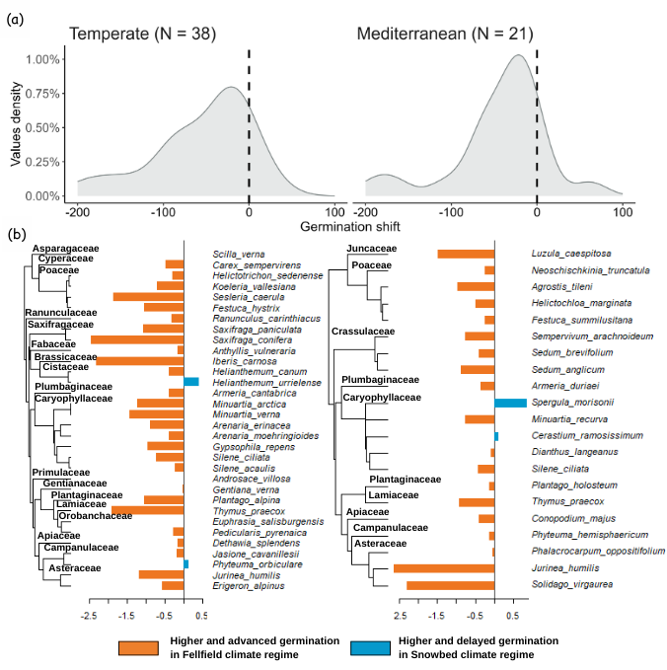

Figure 3. Germination shift in fellfield conditions compared to snowbed conditions in temperate and mediterranean communities.

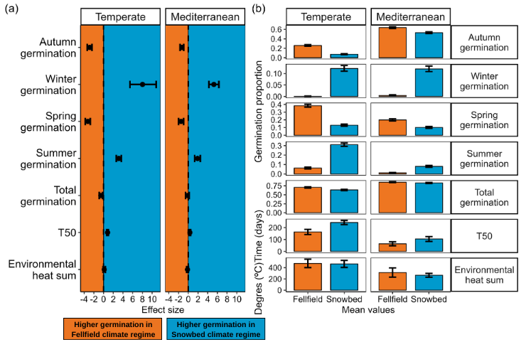

Figure 4. Responses of germination phenology traits to climate regimes in temperate and mediterranean communities.

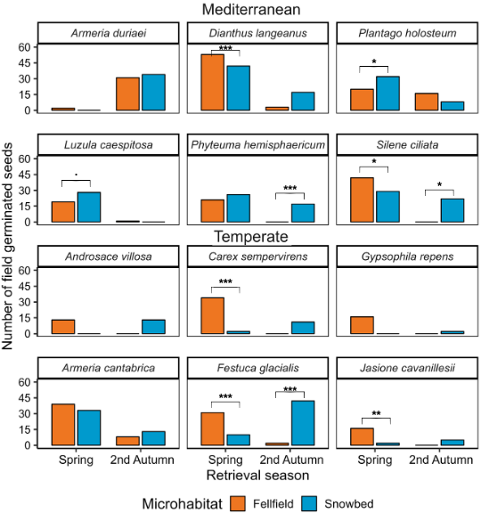

Figure 5. Germination phenology in field sowing experiment.